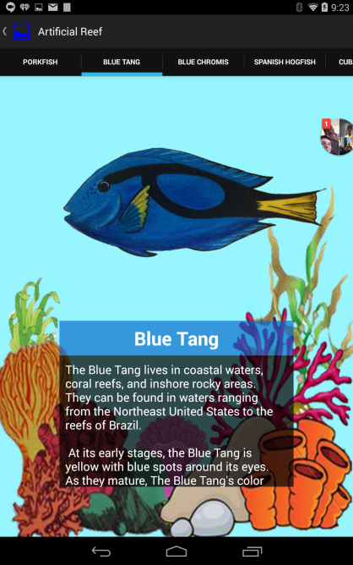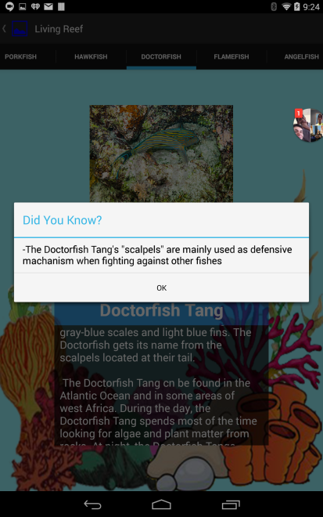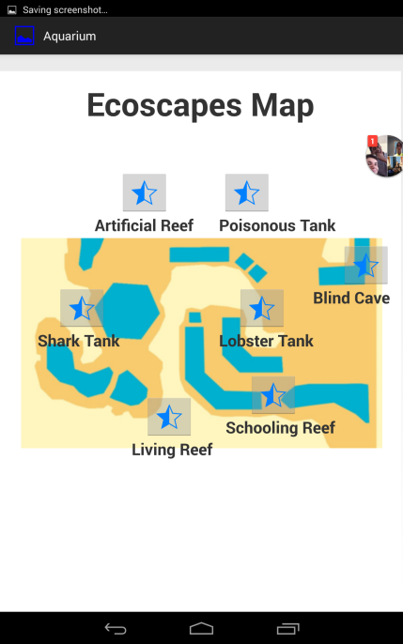**MODs Aquarium App**

**When the user first opens this app, there are 7 stars that each represents a different exhibit in the museum. Each location displays a certain type of animals. When the user clicks on a star, he/she can view the types of animals in that exhibit. And for every animal the user can read a short 1-2 paragraphs of text at the**  **bottom of the screen about the animal and the user can scroll horizontally to view the other animals in that exhibit. Users can also tap on the animal to read a special “Did-You-Know” fact, which displays special facts about the animal. There’s also a button in the top right corner, that when pressed displays a tab titled “Settings”. When the user clicks on this, nothing will happen.**

**MODs Bug App**

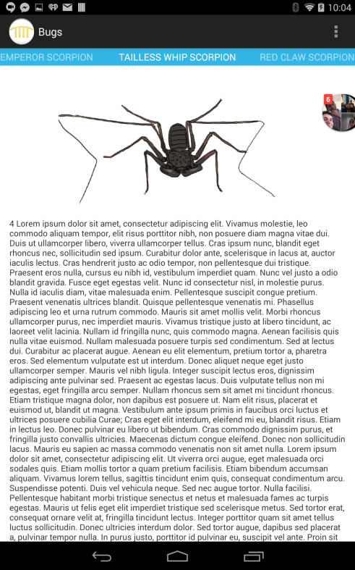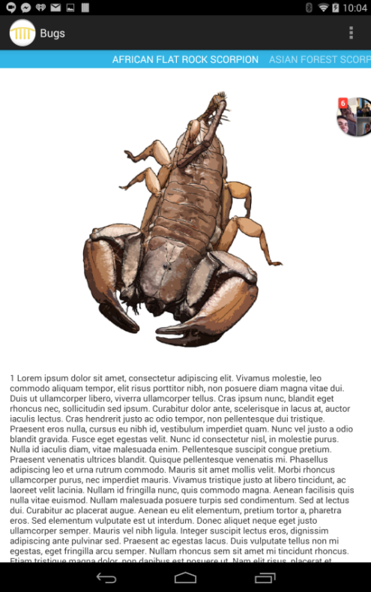

**The app only displays different types of bugs and is very similar to the aquarium app. For every bug, it displays a picture of it and some scrollable small text that the user can view. There is also an action bar so that the user can swipe between the different kinds of bugs, and each bug is also labeled in numerical order as indicated by the text below the pictures. There’s also a button on the top right hand corner that displays a “Settings” tab, but nothing happens when you tap on it.**

**Detection Robot**

**When this app is first launched, it displays a blank white screen, and then when the user taps on the screen, it opens up a camera. When the user taps again, it takes a picture. Once a picture has been taken, the app scans the pictures for any green pixels, and using the RGB color scheme, it shades purple any region containing those green pictures.**

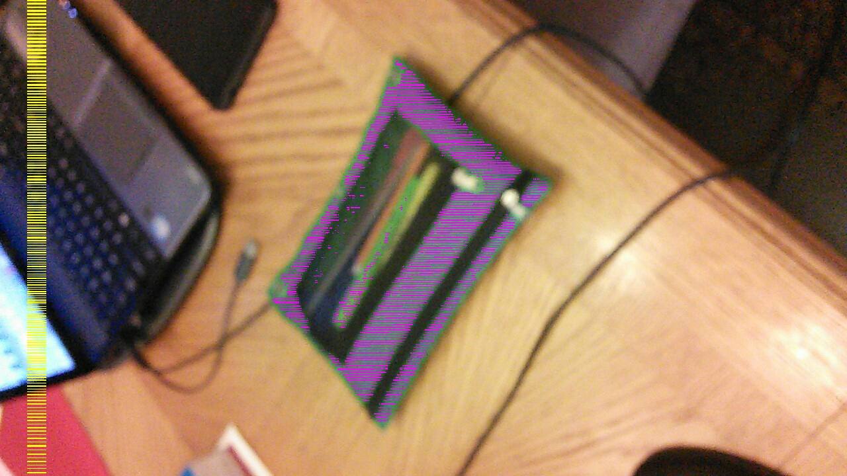

**This robot can also calculate distance. Using the image it takes captured by its camera. It calculates the farthest region containing green pixels and returns the distance from the camera in cm, and it’s displayed in white text next to the yellow bars. It first prints the text “yMax – yMin:” followed by the distance. In this case, the distance was 509 cm.**